Area 2 - Gwinnett County Council of PTAs
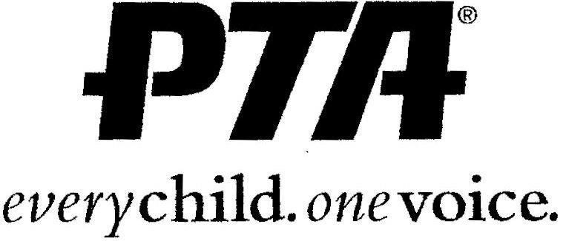

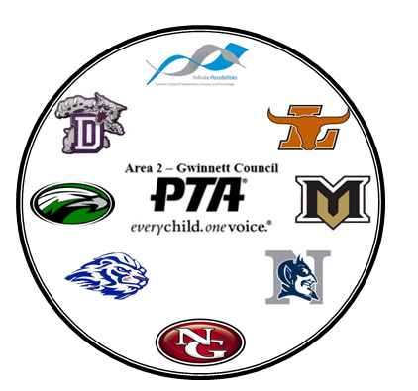
2020 - 2021 High School Scholarship Application
Theme: “Dream Big”
http://www.area2gwinnettpta.org

Mailing Address:
Area 2 Gwinnett County Council of PTAs
320 Town Center Avenue, Suite C-11, #278 Suwanee, GA 30024

Area 2 High School Scholarship Committee
1stvp@area2gwinnettpta.org
Stacey Stacy, Area 2 Vice President

Appl
icant Name:

School:

2020-21 HS SCHOLARSHIP APPLICATION

AREA 2 GWINNETT COUNTY COUNCIL OF PTAs
The membership of the Area 2 Gwinnett County Council of PTAs voted to change the scholarship program, which awards funds to high school seniors planning to attend an accredited two or four-year college or university. The purpose of this High School Scholarship is to assist in rebranding the importance of education for our students in Gwinnett County Public Schools.
Only members of Parent Teacher Associations (PTAs) that are in Good Standing in the Area 2 Council are eligible to apply. Any student from any of the school clusters in our Council are encouraged to apply.
2020-21 Grant funding will be awarded as:
$750 scholarship for 1 graduating high school senior in each of our 8 high schools

HIGH SCHOOL STUDENT SCHOLARSHIP: Solely funded through local council membership and council contributions, Area 2 is proud to present eight (8) $750.00 scholarships to deserving high school seniors who have successfully met or exceeded the State of Georgia graduation requirements, and plan to continue their education by attending an accredited two or four-year college or university, vocational/trade school, or pursue other post-graduate education/training.
This is a one-time, non-renewable scholarship.
ELIGIBILITY
A student is eligible to apply for the Gwinnett Area 2 PTA Scholarship if he/she:
□ Is a graduating senior of an Area 2 high school with a PTA/PTSA;
- The PTA must be in good standing (i.e. paid dues, approved bylaws on file);
- The student and at least 1 adult from their household must be a PTSA member;
- Is interested in attending an accredited four-year (4) or two-year (2) college or university; vocational/trade school, or pursue other post-graduate education/training;
- Has a satisfactory scholastic record acknowledged by an administrator, counselor, or teacher.

INSTRUCTIONS

Each applicant will complete the application and write an essay to answer the following:

What dreams do you have that, if fulfilled, would have the biggest impact on the world?

Applications can be printed from the Area 2 website: (www.area2gwinnettpta.org) and completed legibly by hand. Each application will be scored based upon the response to the essay question. Responses must be legible.
Deadline: Postmarked by Saturday, March 6, 2021.

All applications must be mailed to: Area 2 Gwinnett Council of PTAs
(Attention: Scholarship Committee)
320 Town Center Avenue, Suite C-11, #278
Suwanee, GA 30024

PLEASE ENSURE YOUR SUBMISSION INCLUDES:
- Each completed essay (maximum 850 words), the scholarship information page, and a photocopy of a PTSA Membership Card for the student and 1 guardian in the household, or a copy of the electronic proof of a paid membership from My Payments Plus or Voluntary Contribution Form.
- Certified High School Transcript. It should include all academic credit towards a high school diploma through the first semester or quarter of the 12th grade, numeric and percentage GPA, High School Graduation Test scores (HSGTs), and identify the diploma track (i.e. International Baccalaureate, Advance Placement, College Preparatory or Technology).
- Two Letters of Recommendation: One letter from an administrator, counselor, or high school teacher acknowledging your scholastic attributes/qualities, and One letter from an adult nonfamily member/mentor acknowledging the character of the student.

2020 – 21 HS SCHOLARSHIP APPLICATION AREA 2 GWINNETT COUNTY COUNCIL OF PTAs

STUDENT INFORMATION:
NAME:
________________________________________________________________________________
STREET ADDRESS:
________________________________________________________________________________
CITY: _______________________ ZIP CODE: _____________ PHONE: ( )_________________
EMAIL ADDRESS:
________________________________________________________________________________
PARENT’S NAME:
________________________________________________________________________________ PARENT’S PHONE NUMBER: ( ) ________________________
PARENT’S EMAIL ADDRESS:
________________________________________________________________
SCHOOL NAME:
________________________________________________________________________________
Please check the boxes below to acknowledge that the following items are being submitted with your application.
- Copy of PTSA Membership Card or MyPaymentPlus print-out of PTSA membership purchase
- Certified High School Transcript
- Two Letters of Recommendation
STUDENT SIGNATURE ___________________________________________ DATE _________________

LIST ALL COLLEGES, UNIVERSITIES, AND/OR TECHNICAL SCHOOLS THAT YOU HAVE APPLIED TO AND THE STATUS OF EACH APPLICATION.
SCHOOL APPLIED TO | STATUS OF APPLICATION
Maximum word count: 850 words

2020 – 21 HIGH SCHOOL SCHOLARSHIP APPLICATION AREA 2 GWINNETT COUNTY COUNCIL OF PTAs

ESSAY QUESTION: In the future, I will…

