AREA 2 GWINNETT COUNTY COUNCIL OF PTAs 2022-23
OUTSTANDING EDUCATOR NOMINATION FORM

The Outstanding Educator Award may be awarded to any superintendent, administrator, faculty member or school board member serving in any one of the 44 Local Units of the Area 2 Gwinnett County Council of PTAs. The nominee must be a PTA member and demonstrates professional excellence and commitment to the Mission and Purposes of PTA.

An OUTSTANDING EDUCATOR from Area 2 will be named for each level of education – Elementary, Middle, and High School.

This form must be completed with no more than 10 total pages of supporting documentation to all award criteria to be considered for judging. If your nominee is a winner, the Local Unit PTA/PTSA President will be notified.

The completed nomination form & a copy of the Nominee’s GA PTA membership card, with no more than three additional pages, must be MAILED TO:
AREA 2 GWINNETT COUNTY COUNCIL OF PTAs
ATTN: 2021-22 AWARDS
320 TOWN CENTER AVENUE, SUITE C-11, #278
SUWANEE, GA 30024
Or email: secretary@area2gwinnettpta.com

COMPLETED APPLICATIONS INCLUDING ALL SUPPORTING DOCUMENTS MUST BE POSTMARKED BY FRIDAY, MARCH 10, 2023
This award will be presented at the 2022-23 Area 2 Gwinnett County Council of PTAs Spring Awards Banquet.
Elementary Nominee Middle School Nominee High School Nominee

Name of Nominee ___________________________________________________________________
School Name/PTA____________________________________________________________________
Local Unit # _____________________________ PTA/PTSA President ___________________________
School Address _______________________________________________________________________
City ________________________________________ Zip Code ________________________
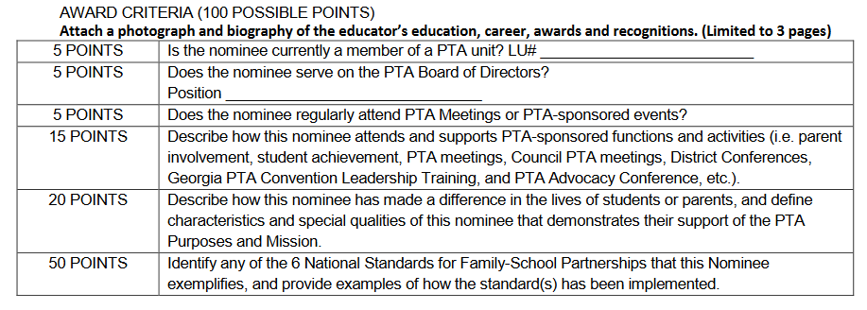

LU Name ______________________________ Principal Name_____________________________
Name & Office of Person Submitting Application___________________________________________
Email Address ________________________________________ Contact Phone ___________________

AREA 2 GWINNETT COUNTY COUNCIL OF PTAs 2022-23 OUTSTANDING EDUCATOR NOMINATION SCORE CARD
Elementary Nominee Middle School Nominee High School Nominee
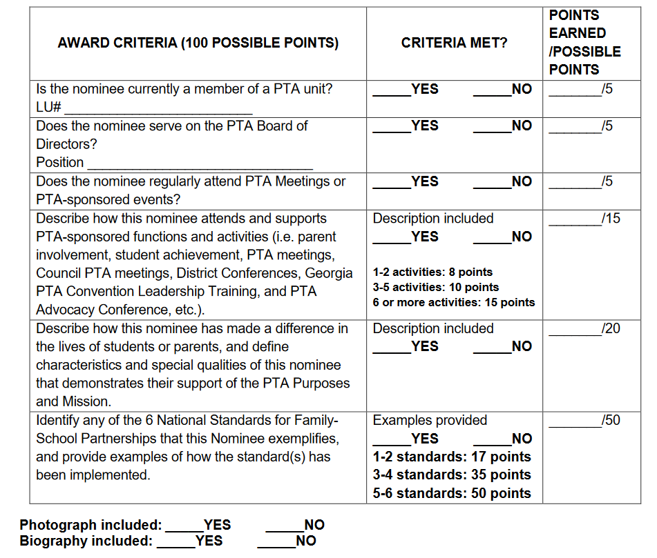

LU Name ______________________________ Principal Name_____________________________

Name & Office of Person Submitting Application___________________________________________

Email Address ________________________________________ Contact Phone ___________________

