AREA 2 GWINNETT COUNTY COUNCIL OF PTAs 2022-23 OUTSTANDING SCHOOL NURSE NOMINATION FORM
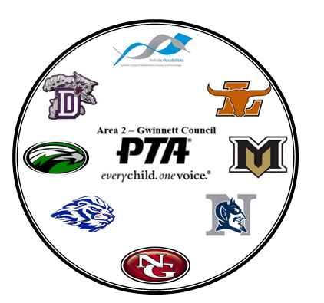
School nurses provide substantial medical care and offer critical services
for the students of Georgia’s public schools. In recognition of National
School Nurse Day in May, Area 2 Gwinnett County Council of PTAs will
honor one (1) OUTSTANDING SCHOOL NURSE in elementary, middle,
and high school from one of 44 local units in the council. For the purpose
of this award, a school nurse is anyone who provides health care services
for students on a full or part time basis at the local school. The nominated
School Nurse must be a PTA member.

If your School Nurse is a PTA member, and supports the mission of PTA,
please complete this form and submit to Area 2 Gwinnett County
Council of PTAs, ATTN: 2022-23 AWARDS, 320 Town Center Avenue,
Suite C-11, #278, Suwanee, GA 30024 or
email: secretary@area2gwinnettpta.com on or before Friday, March 10, 2023. A panel of judges will select the winners. If your nominee is a winner, the PTA/PTSA President will be notified.

This award will be presented at 2022-23 Area 2 Gwinnett County Council of PTAs Spring Awards Banquet.

Elementary Nominee Middle School Nominee High School Nominee

School Name/PTA____________________________________________________________________
Local Unit # _____________________________ PTA/PTSA President ___________________________
School Address _______________________________________________________________________
City ________________________________________ Zip Code ________________________
Name of School Nurse ________________________________________________________________
Number of Years as a School Nurse at this School_______ Number of Years as a School Nurse________

Attach a photograph and biography of the nurse’s education, career, awards, and recognitions.

All applications must be complete at time of submission and the following criteria must be met:

• Use letter-size, 8 1⁄2” x 11” paper, one side only for each of the following statements. Include the PTA unit’s name and LU ID# in the top right corner of each page.

• Prepare a statement about the school nurse. The statement should tell us how your school nurse makes a significant difference in the lives of students in your school. It should be typed, double spaced with 1” margins, 12 pt. Times New Roman font, not to exceed two pages.

• Include up to 5 student statements with your local unit’s nomination. Student statements should describe how your school nurse helps students. Each student statement should not exceed 100 words for elementary students (K-5) or 200 words for middle or high school students (6-12). If typed, the student statements must be double spaced with 1” margins, 12 pt. Times New Roman font. If handwritten, please write or print clearly.

LU Name ____________________________________Principal Name____________________________________
Name & Office of Person Submitting Application____________________________________________________
Email Address _____________________________________Contact Phone _______________________________

